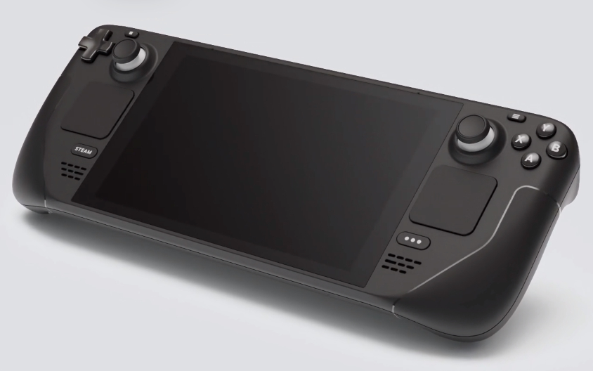
104 - Controls - Gunner - Joystick
U=Up, D=Down, F=Forward, B=Backward, L=Left, R=Right, P=Press, S-*=Shift-*, L-*=Long-*

D-pad
- U: --
- D: --
- L: --
- R: --
Left stick
- Axes: --
- P (L3): --
Right Stick
- Axes: --
- P (R3): --
ABXY buttons
- A: --
- B: --
- X: --
- Y: --
Left Trackpad
- P: --
Right Trackpad
- P: --
L1 shoulder
- P: --
L2 trigger
- Axis: --
- P: --
L4 rear button
- P: --
L5 rear button
- P: --
R1 shoulder
- P: --
R2 trigger
- Axis: --
- P: --
R4 rear button
- P: --
R5 rear button
- P: --

